Generative AI for Wireless and Energy Systems: A Diffusion Model Perspective

Zhu Han, ECE Department and CS Department, University of Houston

Abstract: Diffusion models have rapidly evolved from image generators into a general framework for modeling complex data distributions. This talk presents three complementary directions that extend diffusion models beyond conventional generation and toward system-level intelligence. First, we revisit the reverse diffusion process through the lens of mean-field games, where denoising is reformulated as an optimal population-level transport problem between noise and data distributions. This perspective connects diffusion generation with controlled distribution evolution, saddle-point optimization, and coupled HJB–FPK dynamics. Second, we show how latent diffusion inpainting can reconstruct UAV radio maps from sparse and partial observations. By combining UAV-based sensing, spatio-temporal latent diffusion, and radio map reconstruction, diffusion models become a tool for recovering hidden wireless environments under limited coverage and dynamic sensing constraints. Third, we introduce socio-aware diffusion for residential load data generation, where social attributes guide controllable generation for disadvantaged or data-scarce communities. Through global-personalized multi-step diffusion and fairness-oriented adversarial training, the model generates realistic and diverse electricity-consumption patterns while improving downstream forecasting and reducing data imbalance. Together, these works highlight a broader view of diffusion models: not merely as sample generators, but as controllable and conditional for reasoning about evolving distributions in large-scale infrastructure systems, including wireless networks and smart grids.
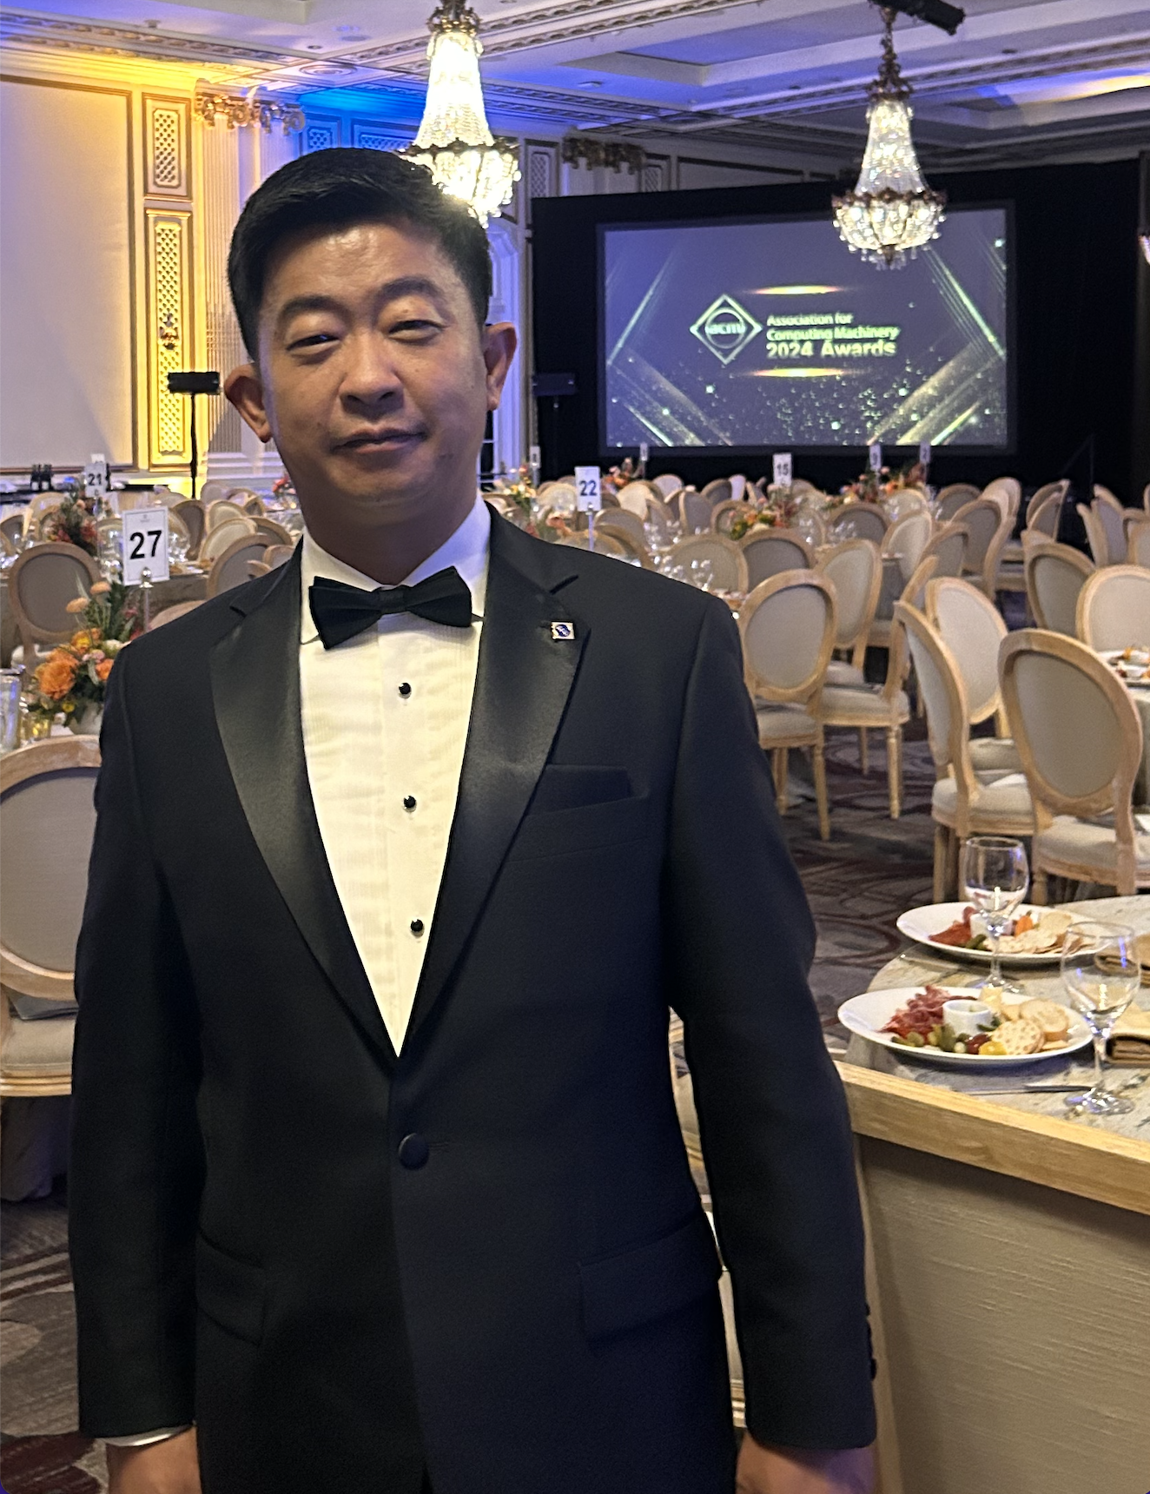
Bio: Zhu Han received the B.S. degree in electronic engineering from Tsinghua University, in 1997, and the M.S. and Ph.D. degrees in electrical and computer engineering from the University of Maryland, College Park, in 1999 and 2003, respectively. From 2000 to 2002, he was an R&D Engineer of JDSU, Germantown, Maryland. From 2003 to 2006, he was a Research Associate at the University of Maryland. From 2006 to 2008, he was an assistant professor at Boise State University, Idaho. Currently, he is a John and Rebecca Moores Professor in the Electrical and Computer Engineering Department as well as the Computer Science Department at the University of Houston, Texas. Dr. Han is an NSF CAREER award recipient of 2010, and the winner of the 2021 IEEE Kiyo Tomiyasu Award. He has been an IEEE fellow since 2014, an AAAS fellow since 2020, ACM fellow since 2024, an IEEE Distinguished Lecturer from 2015 to 2018, and an ACM Distinguished Speaker from 2022-2025.

